- GCP VM details. aimlde-vm is used for development and grocerye2e-vm is used as production server in CI/CD pipeline.
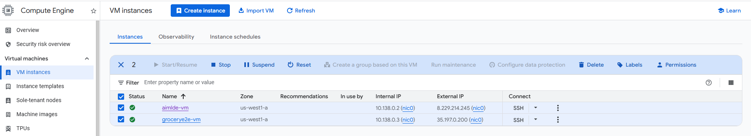
- aimlde-vm containers up and running.

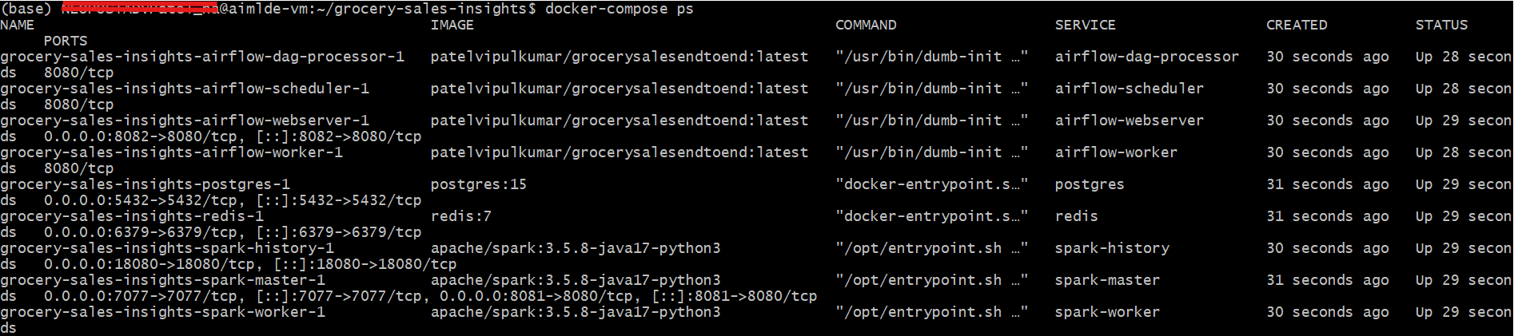

- Airflow Dashboard
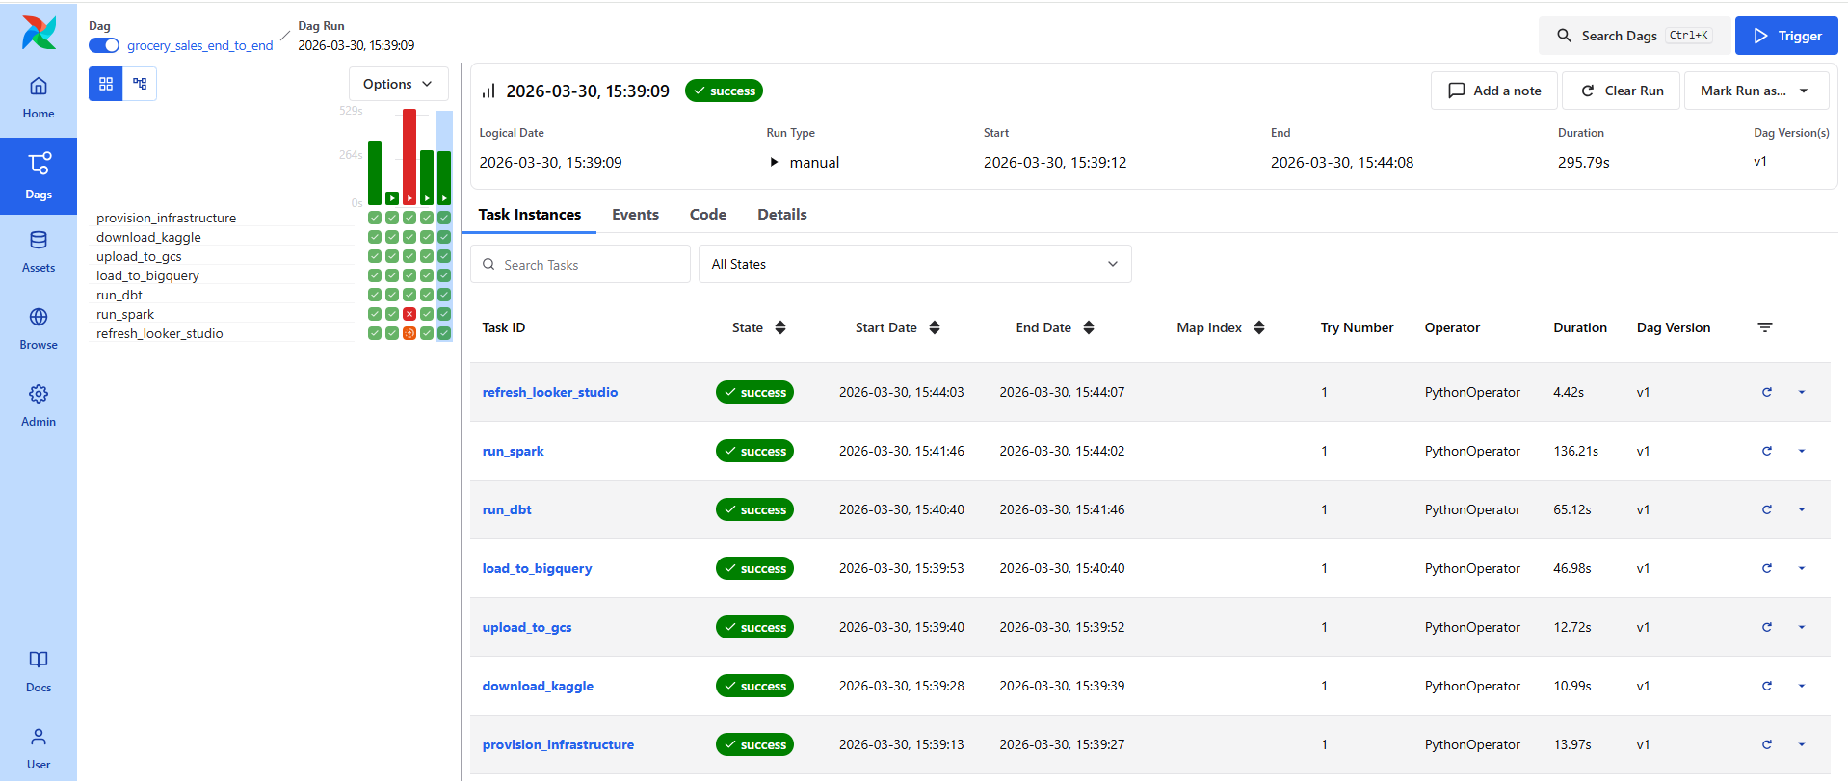
- Spark Master
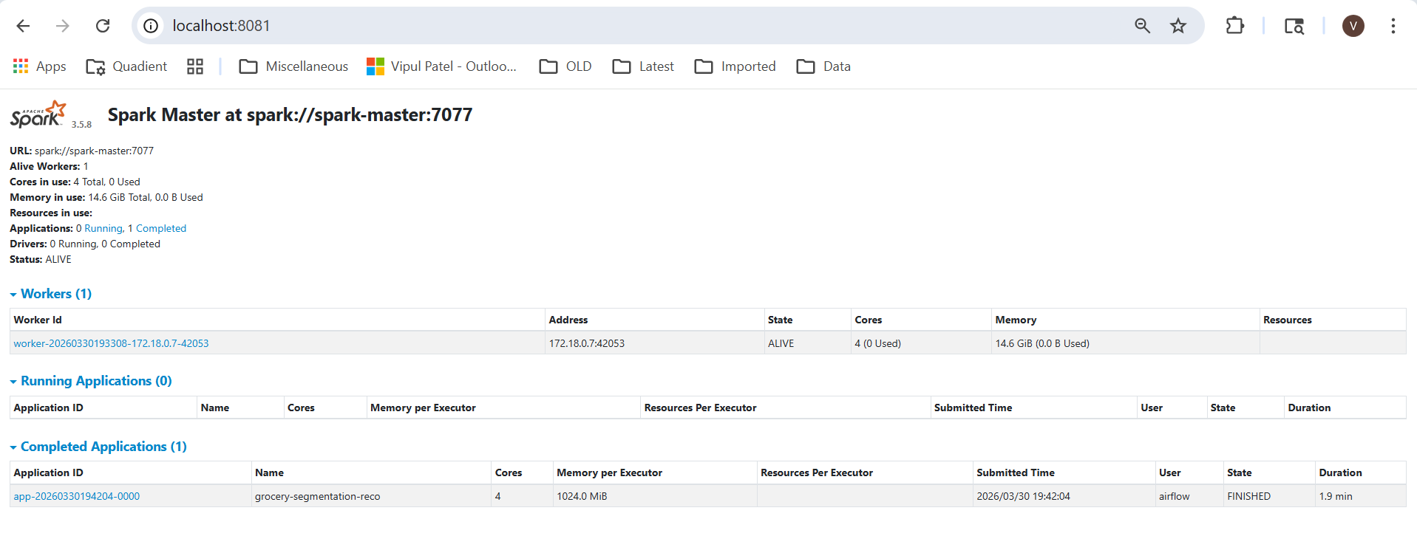
- Spark History Server

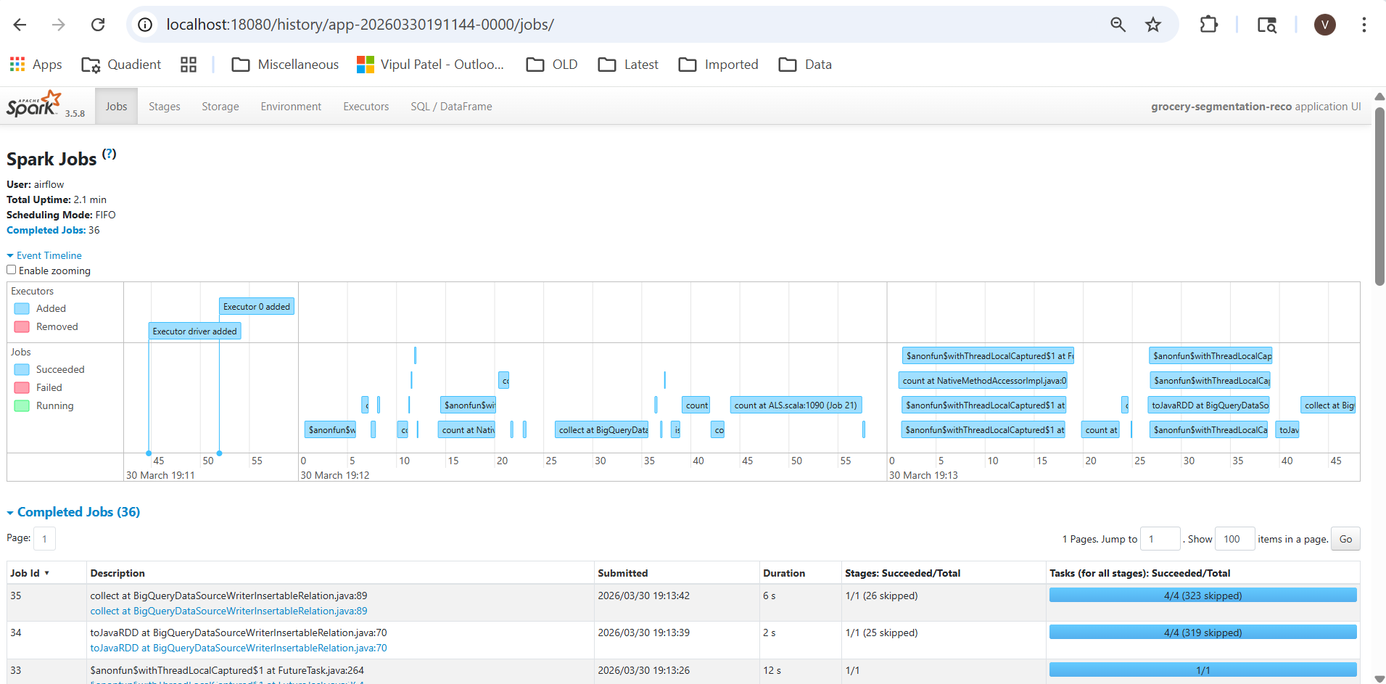

- BigQuery dataset provisioned through Terraform in Airflow and tables generated through dbt models.
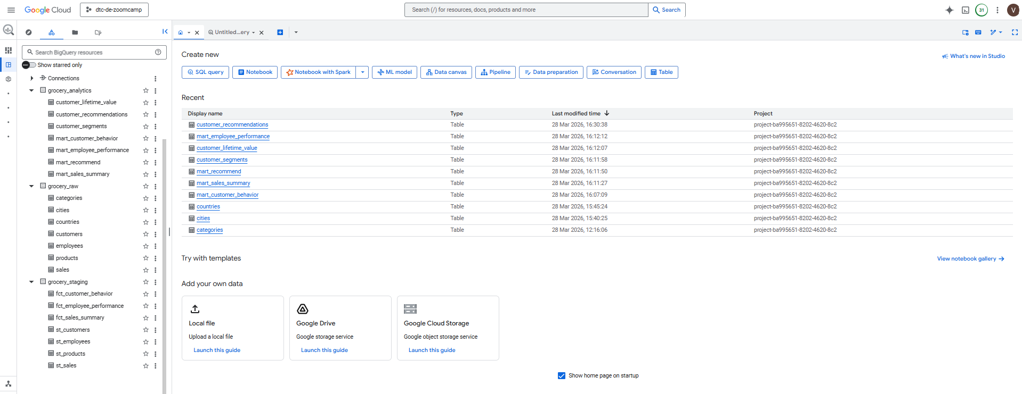

- Google Cloud storage bucket provisioned through Terraform and several files ingested through Airflow
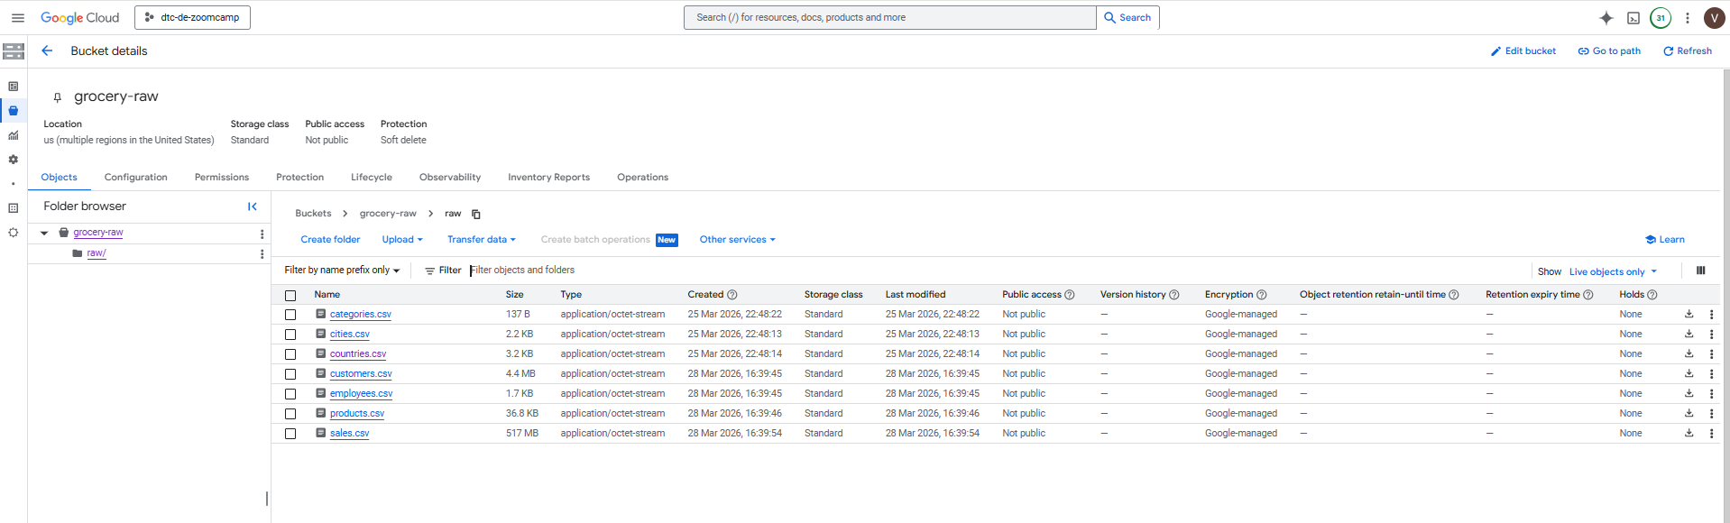

- Looker Studio Dashboard utilizing datasets google_analytics from BigQuery.
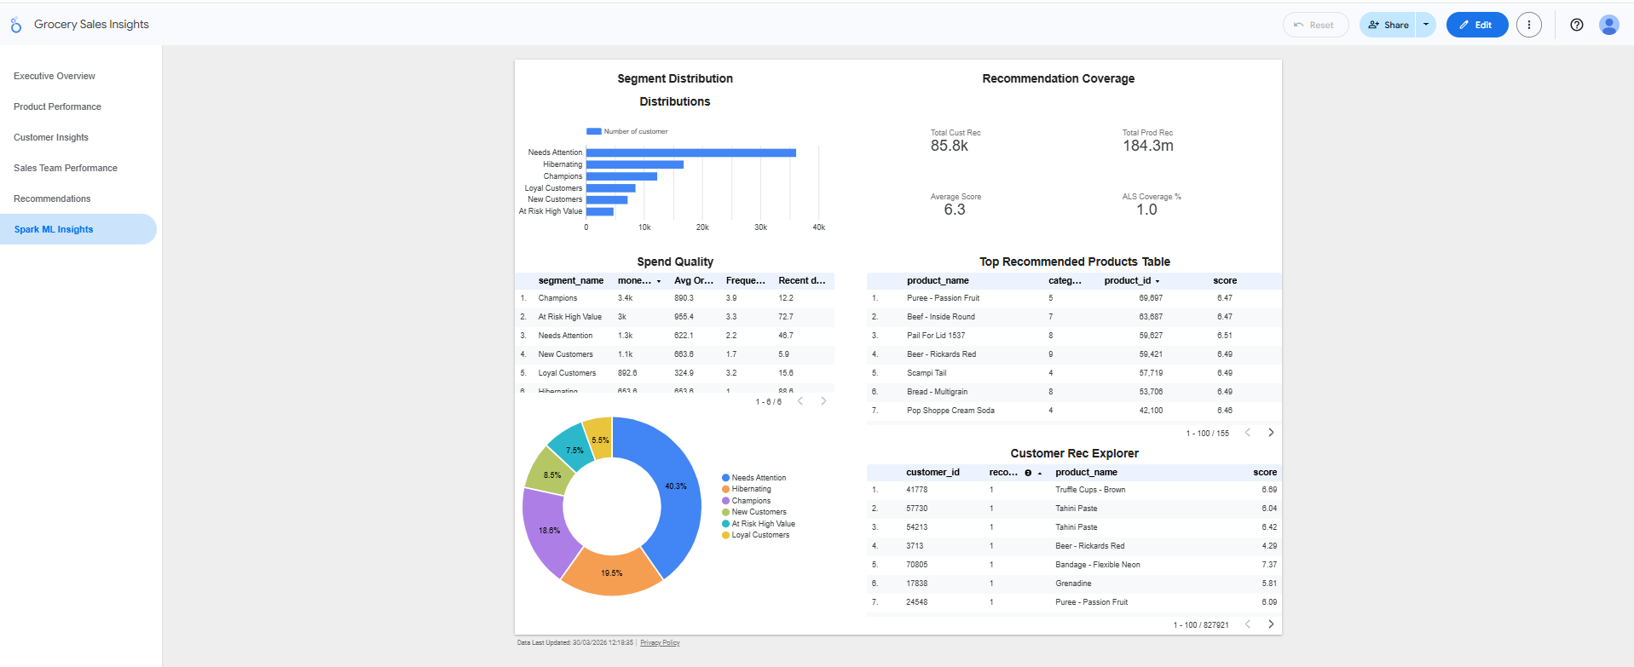

- CI/CD GitHub Workflow
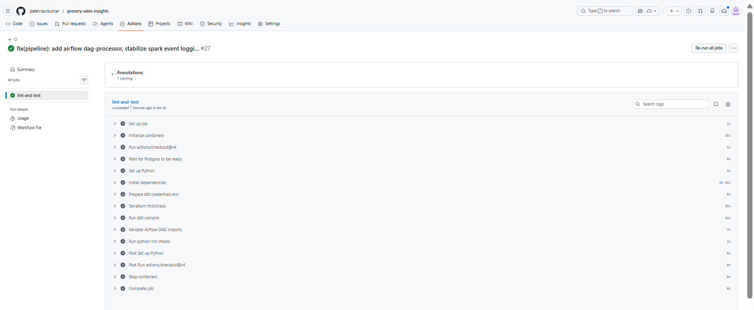

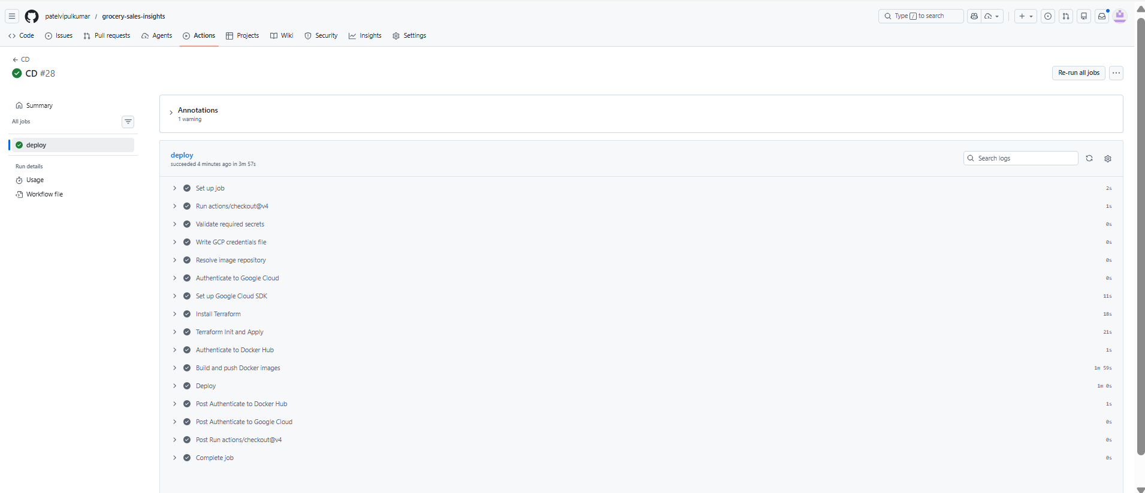

- Running container details on deployment server grocerye2e-vm

